PXO: Poly-XTAL operations V10.00. Free MATLAB codebase to generate and analyse complex 2D poly-crystalline grain structures

**INTRODUCTION AND FUNCTIONALITITES**

Sunil Anandatheertha1

1PhD student, Faculty of Engineering and Computing, Coventry University, Coventry CV1 5FB, UK

**Author contributions**

|  |  |
| --- | --- |
| Sunil Anandatheertha | Conceptualization, Software development and maintenance, documentation and manuscript preparation |

**Table of Contents**

1.1. Highlights 2

1.2. Abstract 3

1.3. Background and motivation 3

1.4. Functionalities 4

1.5. Capabilities 4

1.6. Applications 5

1.7. Available workflow paths for materials scientists 5

1.8. Theory, pseudo-code and implementation 6

1.8.1. Q-state Pott’s model 6

1.8.2. Boundary condition 7

1.9. Kernel weight functions 8

1.10. Functionalities and capabilities for grain structure analysis in Poly-XTAL Operations 10

1.10.1. Grain segregation 10

1.10.2. Making 2nd phase particles 11

1.10.3. Making grain structures for CPFEM using Poly-XTAL Operations 12

1.11. Functionalities and capabilities enabled by 3rd party MATLAB libraries 12

1.11.1. Analysing Poly-XTAL Operations generated grain structure in MTEX 12

1.11.2. Making grain structures for CPFEM using mtex2gmsh 13

1.12. References 13

1.13. Appendix-A: Gallery 14

**Table of figures**

Figure 1: Numbering conventions used on the square lattice for theory and implementation 6

Figure 2: Illustration of boundary condition (a) rectangular grid (b) toroidal boundary condition with torsion $τη=0$ and $τζ=0$ (c) toroidal boundary condition with $τη=π2$ and $τζ=0$ 7

Figure 3: Boundary conditions (a) Peripheral type (b) Internal type 8

Figure 4: Example values of Kernel weight function parameters 9

Figure 5: Visualization of the Kernel weight matrix elements $Wij$ (a-i) and temporal slices of grain structure at Tsim. = 500 and 1000 evolved by using $Wij$ 10

Figure 6: (a, b) State wise partitioned number of grains at Tsim. = 500 and 1000 respectively (c & d) statistics of the number of grains at Tsim. = 500 and 1000 (e, f) grain size statistics at Tsim. = 500 and 1000 (g) temporal evolution of number of grains 11

Figure 8: Types of 2nd phase particles which can be made: (a) Straight and thin nanotubes/needles, (b) Wavy and thin nanotubes, (c) Straight and thick nanotubes, (d) Wavy and thick nanotubes, (e) Nanotubes, Single lattice site particles and dense lattice site particle clusters and (f) Nanotubes, Single lattice site particles and single lattice site particle clusters 11

Figure 7: Grain structure exchange between Poly-XTAL Operations 9.04 and MTEX 5.04 (a) Poly-XTAL Operations (b) Grain boundary mis-orientations calculated using MTEX (c) MTEX calculated grain shape distribution for the grain structure made in Poly-XTAL Operations 9.04 12

Figure 9: (a) Grain structure in Poly-XTAL Operations (b) Region inside the grain structure (c and d) Triangular and Quadrilateral mesh for the highlighted region in the grain structure, made using mtex2gmsh routine called from MTEX 5.04 13

Figure 10: Few example temporal slices of partitioned space having a maximum of 2 unique states. 14

Figure 11: Few example temporal slices of partitioned space having a maximum of 32 unique states 15

## Highlights

* Free MATLAB codebase for researchers working on computational materials science, computational geology, dynamics of importance sampling Monte-Carlo schemes and graphenes.
* Make spatiotemporally gradient 2D grain structures and associate spatiotemporally gradient crystallographic texture to the grain structure
* Export ABAQUS input file for use in CPFEM
* Work with Ising model and Q-state Pott’s model simulation on square lattices
* Call MTEX libraries and mtex2gmsh

## Development history

1. The 1st version to generate grain structures was written in 2010 in the department of mechanical engineering at PESIT, Bengaluru, India when employed as Junior Research Fellow. The original codes were uploaded to internet in 2012 and can be found here:
   1. <https://uk.mathworks.com/matlabcentral/fileexchange/34784-monte-carlo-simulation-of-two-dimensional-grain-growth-code-version-no-1-basic?s_tid=prof_contriblnk>
   2. <https://uk.mathworks.com/matlabcentral/fileexchange/34985-monte-carlo-simulation-of-three-dimensional-grain-growth-code-version-no-1-basic?s_tid=prof_contriblnk>
2. 2nd to 7th version were written during 2013 – 2014 in the department of aerospace engineering at Indian Institute of Science and department of mechanical engineering, Nagarjuna college of engineering and technology; for my master’s project, under the guidance of Dr. G Narayana Naik and Dr. N G Subramania Udupa. A copy of my master’s thesis can be made available upon request.
3. 8th version was developed during 2015 – 2016 in the department of mechanical engineering at PES University.
4. Version 9 and above were written over the course of my PhD. I decided the name “Poly-XTAL Operations” to be a very general name which could represent the entirety of the functionalities both present then and thought of to be included in future.

* **Sunil Anandatheertha**

**13-01-2021**

## Abstract

Computational materials science researchers who study multi-scale thermo-mechanical and texture behaviour of poly-crystalline materials need parametric and realistic geometric morphologies of the constituent phases reflected in grain structure. A virtual grain structure is often used by them as an input to further studies such as crystal plasticity based finite element analysis and other multi-physics studies. Though simplified and geometric grain structures have been used, there exists no tool to generate the spatial gradients in grain structure and texture as observed in the real world. This work presents a MATLAB package which users can use to create parametric temporally randomized spatially gradient grain structures and crystallographic texture. In addition to various in-built tools, ‘Poly-XTAL Operations’ can output in a format which can be opened in further 3rd party open source MATLAB based libraries such as MTEX to tend to their specific requirements. This package will also be a valuable tool for researchers working in importance sampling (discrete and continuous) Monte-Carlo techniques and geologists interested in modelling planet’s crust and soil behaviour. This paper briefs the basics for using ‘Poly-XTAL Operations V9.04’ and provide examples to understand the capabilities and enable easy usage. Functionalities, capabilities and possible applications are listed. Theory, structure, format and commands are explained. Links to repository, results gallery and detailed documentation are provided.

**Keywords**: (1) Poly-XTAL Operations (2) Grain structures (3) Ising model (4) Q-State Potts model

## Background and motivation

Mathematicians, statistical mechanists and computational materials scientists are interested in studying the spatiotemporal evolutionary aspects of multi-phased partitioning of an n-dimensional space. We give four examples for this.

The 1st example is from mathematics where researchers are interested in the chaotic partitioning of a n-D bounded spatial domain and its spatiotemporal evolution under some governing rules.

The 2nd example is from statistical mechanics, the very well-known Ising model of the importance sampling Monte-Carlo techniques studying the spatiotemporal evolution of the kinetics and thermodynamics of the distribution of two phases in a lattice. Exact solutions have been developed for such simple models involving 2 states [1], but for more complex models like the Q-state Pott’s model, an exact model is impractical due to the vastness of the solution space.

The 3rd example is from fundamental computational materials science where researchers are interested in grain growth [2], where the temporal evolution of the spatial and thermodynamical parameters of multi-phase grain structures [3,4] is studies. A part of this research also touches upon understanding the kinematic and kinetic behaviour of insoluble 2nd phase particles in grain structures [5] and how they interact with the grain boundaries. Some of these studies have tried to validate empirical models of grain structure geometry such as the Zener equation [6]. As the shape of the particles influence the Zener drag working against grain boundary evolution during grain growth [7], and that nature presents irregularly shaped particles, computer models which can consider such particle shape and their spatial distribution becomes very essential.

The 4th example is from applied computational materials science where researchers need poly-crystalline grain structures to be used in techniques such as crystal plasticity based finite element analysis in order to study material’s phase-partitioned thermo-mechanical response and texture evolution under applied thermo-mechanical loads [8]. Though Voronoi tessellated geometries of grain structures have been used before in crystal plasticity-based simulations, they are simplifications and do not accurately represent the geometric irregularities presented by nature.

## Functionalities

1. Generate multi-phase 2D poly-crystalline grain structure. Ability to create:
   1. morphologically anisotropic grains
   2. spatially gradient grain morphologies in grain structure
2. Importance sampling Monte-Carlo on lattice to make realistic grains
   1. Ising model
   2. Q-state Potts model
3. Generate Voronoi equivalent of simulated and EBSD acquired grain structure
4. Consideration of following in grain growth simulation
   1. Artificial temperature gradients
   2. Spatiotemporal tracking of lattice energy
5. Grain identification and grain size statistics
6. Call MTEX libraries to:
   1. create spatial gradients in texture
   2. take advantage of its grain structure analysis routines native to MTEX
   3. carry out texture analysis
7. Export finite element mesh to ABAQUS input file for CPFEM studies using:
   1. in-built routines
   2. mtex2gmsh which uses gmsh

## Capabilities

1. Store multiple temporal slices of grain structures on square lattices
2. Study grain boundary pinning from point particles, fully packed and sparse particle clusters (regular), thin and thick whisker reinforcements and nanotubes
3. Achieve spatial gradients in 2D Voronoi grain structure
4. Domain reduction by sparsing and sub-domain extraction
5. Open temporal slices of grain structures generated in Poly-Xtal operations in MTEX and take advantage of MTEX grain structure analysis tools
6. Track temporal evolution of grain structure statistics
7. Track temporal change in total and phase partitioned Hamiltonian
8. Generate tensile testing specimen with grain structure in the test

## Applications

1. Statistical mechanics. Study of Monte-Carlo algorithms and sampling techniques
2. FEM. Material scientists, engineers and geologists need realistic grain structures for further analysis such as crystal plasticity based finite element analysis.

## Available workflow paths for materials scientists

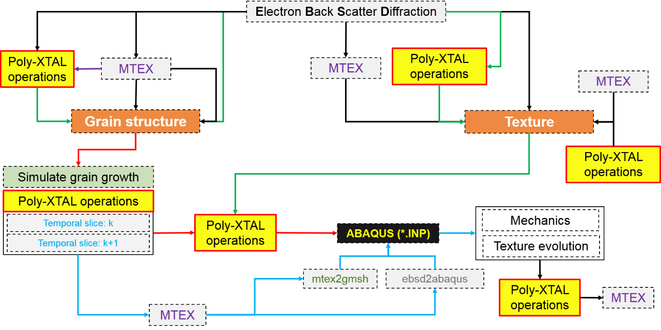

Figure 1:

## Functionalities and capabilities for grain structure analysis in Poly-XTAL Operations

### Grain segregation

Grain structure is characterized using in-built tools. Poly-XTAL Operations can generate important statistics such as number distribution of number of grains (MORE CLARIFICATION NEEDED ON THE NUMBER OF GRAINS) and grain size. Figure 6. Grain segregation is done using frontal algorithm in the present version and is slow by nature for large systems. The code base allows the user to export the grain structure in a format using which grain segregation can be made much faster using in-built MTEX [9] algorithm [10].



Figure 6: (a, b) State wise partitioned number of grains at Tsim. = 500 and 1000 respectively (c & d) statistics of the number of grains at Tsim. = 500 and 1000 (e, f) grain size statistics at Tsim. = 500 and 1000 (g) temporal evolution of number of grains

### Making 2nd phase particles



Figure 8: Types of 2nd phase particles which can be made: (a) Straight and thin nanotubes/needles, (b) Wavy and thin nanotubes, (c) Straight and thick nanotubes, (d) Wavy and thick nanotubes, (e) Nanotubes, Single lattice site particles and dense lattice site particle clusters and (f) Nanotubes, Single lattice site particles and single lattice site particle clusters

Types of 2nd phase particles that are included in Poly-XTAL Operations 9.04 are shown in example lattice grids in Figure *8*(a to f). The individual controlling parameters of such 2nd phase particles called Zener particles are provided in Figure 12 under the sub-structure “**zener**”. Detailed information about these parameters can be found in the technical manual.

## References

[1] R.J. Baxter, Exactly Solved Model in Statistical Mechanics, Academic press, Harcourt Brace Jovanovich, 1989.

[2] D. Weaire, S. Mcmurry, Some Fundamentals of Grain Growth, Solid State Phys. - Adv. Res. Appl. 50 (1996) 1–36. https://doi.org/10.1016/S0081-1947(08)60603-7.

[3] M.P. Anderson, D.J. Srolovitz, G.S. Grest, P.S. Sahni, Computer simulation of grain growth-I. Kinetics, Acta Metall. 32 (1984) 783–791. https://doi.org/10.1016/0001-6160(84)90151-2.

[4] M.P. Anderson, G.S. Grest, R.D. Doherty, K. Li, D.J. Srolovitz, Inhibition of grain growth by second phase particles: Three dimensional Monte Carlo computer simulations, Scr. Metall. 23 (1989) 753–758. https://doi.org/10.1016/0036-9748(89)90525-5.

[5] D.J. Srolovitz, M.P. Anderson, G.S. Grest, P.S. Sahni, Computer simulation of grain growth-III. Influence of a particle dispersion, Acta Metall. 32 (1984) 1429–1438. https://doi.org/10.1016/0001-6160(84)90089-0.

[6] P.A. Manohar, M. Ferry, T. Chandra, Five Decades of the Zener Equation, ISIJ Int. 38 (1998) 913–924. https://doi.org/10.2355/isijinternational.38.913.

[7] W.B. Li, K.E. Easterling, The influence of particle shape on zener drag, Acta Metall. Mater. 38 (1990) 1045–1052. https://doi.org/10.1016/0956-7151(90)90177-I.

[8] F. Roters, P. Eisenlohr, L. Hantcherli, D.D. Tjahjanto, T.R. Bieler, D. Raabe, Overview of constitutive laws, kinematics, homogenization and multiscale methods in crystal plasticity finite-element modeling: Theory, experiments, applications, Acta Mater. 58 (2010) 1152–1211. https://doi.org/10.1016/j.actamat.2009.10.058.

[9] F. Bachmann, R. Hielscher, H. Schaeben, Texture analysis with MTEX- Free and open source software toolbox, Solid State Phenom. 160 (2010) 63–68. https://doi.org/10.4028/www.scientific.net/SSP.160.63.

[10] F. Bachmann, R. Hielscher, H. Schaeben, Grain detection from 2d and 3d EBSD data-Specification of the MTEX algorithm, Ultramicroscopy. 111 (2011) 1720–1733. https://doi.org/10.1016/j.ultramic.2011.08.002.

## Appendix-A: Gallery



Figure 10: Few example temporal slices of partitioned space having a maximum of 2 unique states.



Figure 11: Few example temporal slices of partitioned space having a maximum of 32 unique states